**Phase 6: User Interface Development**

**Lightning App Builder**

**Purpose:** Create customized pages and apps for different user profiles without coding.

**Implementation:**

* **CharityConnect App:** A unified app containing all objects: Donors, Donations, Campaigns, Beneficiaries, Donor Badges, and Impact Cart.
* **Donor Home Page:** Highlights total contributions, loyalty points, and badges earned. Quick access to available campaigns.
* **NGO Staff Home Page:** Provides dashboards with campaign progress, donation totals, and tasks.

**Benefits:** Tailors the experience to user roles, allowing donors and staff to access relevant information quickly. It simplifies navigation and enhances user engagement.

**Record Pages**

**Purpose:** Customize how individual object records are displayed for clarity and usability.

**Implementation:**

* **Donor Record Page:** Displays personal details, donation history, loyalty points, and badges earned.
* **Campaign Record Page:** Shows campaign goal, amount raised, and associated donations.
* **Donation Record Page:** Contains donor, campaign, beneficiary, and amount details.

**Benefits:** Users can view all relevant information at a glance, reducing manual effort and errors.

**Tabs**

**Purpose:** Organize access to objects and functionality in the app.

**Implementation:**

* Tabs for **Donors, Donations, Campaigns, Beneficiaries, and Donor Badges**.
* Optional **Impact Cart tab** for donors to select multiple campaigns.

**Benefits:** Makes navigation intuitive and allows quick access to the most frequently used features.

**Home Page Layouts**

**Purpose:** Provide role-based dashboards and quick action areas.

**Implementation:**

* **Donor Dashboard:** Highlights loyalty points, badges, and recent donations.
* **Staff Dashboard:** Displays campaign goals, donations received, and beneficiary tracking.

**Benefits:** Ensures that both donors and staff can see **key information immediately** without searching through records.

**Utility Bar**

**Purpose:** Offer quick access tools visible across pages.

**Implementation:**

* Added tools for **Create Donation, Add Beneficiary, and View Campaign Performance**.

**Benefits:** Reduces clicks and improves productivity, allowing staff to perform frequent actions from any page.

**Lightning Web Components (LWC)**

**Purpose:** Create dynamic, interactive components that improve engagement.

**Implementation:**

* **Smart Donor Cart LWC:** Donors can select campaigns and see the total donation instantly.
* **Donor Badge Display LWC:** Shows earned badges and loyalty points.

**Benefits:** Provides a **modern, interactive user experience** for donors and staff. Components update dynamically without page reloads.

**Apex with LWC**

**Purpose:** Handle server-side logic and calculations for dynamic UI components.

**Implementation:**

* Apex Controllers fetch donor history for LWC display and calculate badge eligibility.

**Benefits:** Enables **real-time updates** and ensures complex calculations (like badges or loyalty points) are handled efficiently.

**Events in LWC**

**Purpose:** Allow communication between LWC components for interactive updates.

**Implementation:**

* When a donor adds campaigns to the Impact Cart, the **Badge Display component updates automatically** to reflect potential points earned.

**Benefits:** Provides a seamless, interactive experience and ensures the UI reflects changes immediately.

**Wire Adapters & Imperative Apex Calls**

**Purpose:** Retrieve Salesforce data either reactively (wire) or on-demand (imperative).

**Implementation:**

* **Wire Adapter:** Fetches donor’s past donations and displays in dashboard.
* **Imperative Apex Call:** Calculates total donation value when multiple campaigns are selected in the Impact Cart.

**Benefits:** Optimizes performance and provides accurate, real-time data to the user.

**Navigation Service**

**Purpose:** Programmatically control navigation between Salesforce pages.

**Implementation:**

* Donor completes Impact Cart → auto-navigate to **Confirmation Page**.
* Staff clicks “Top Donors” widget → navigate directly to Donor Record Page.

**Benefits:** Reduces unnecessary clicks, improves workflow efficiency, and enhances user experience.

**Screenshots:**

**Lightening app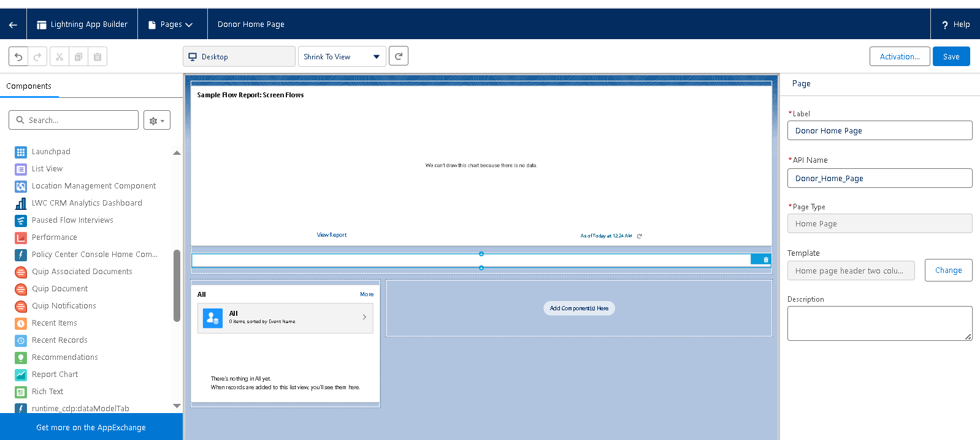Tabs**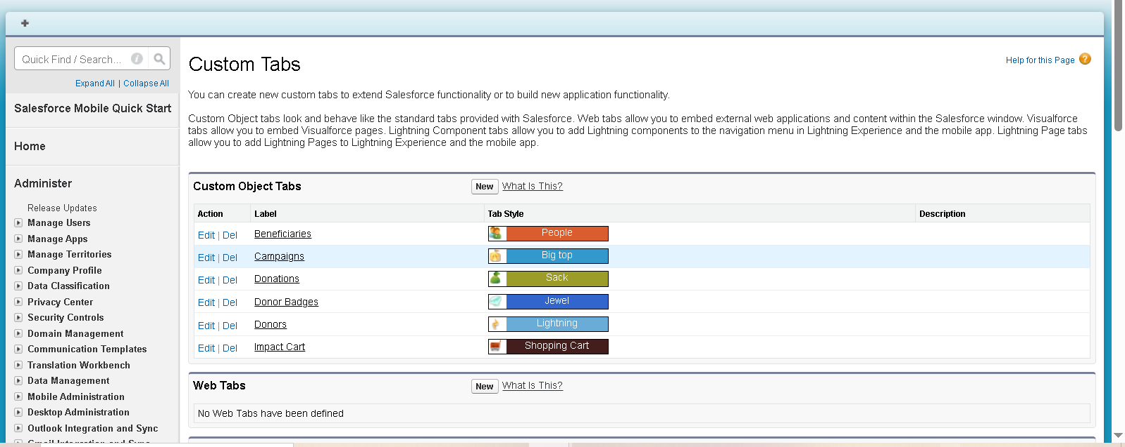

**App layout  
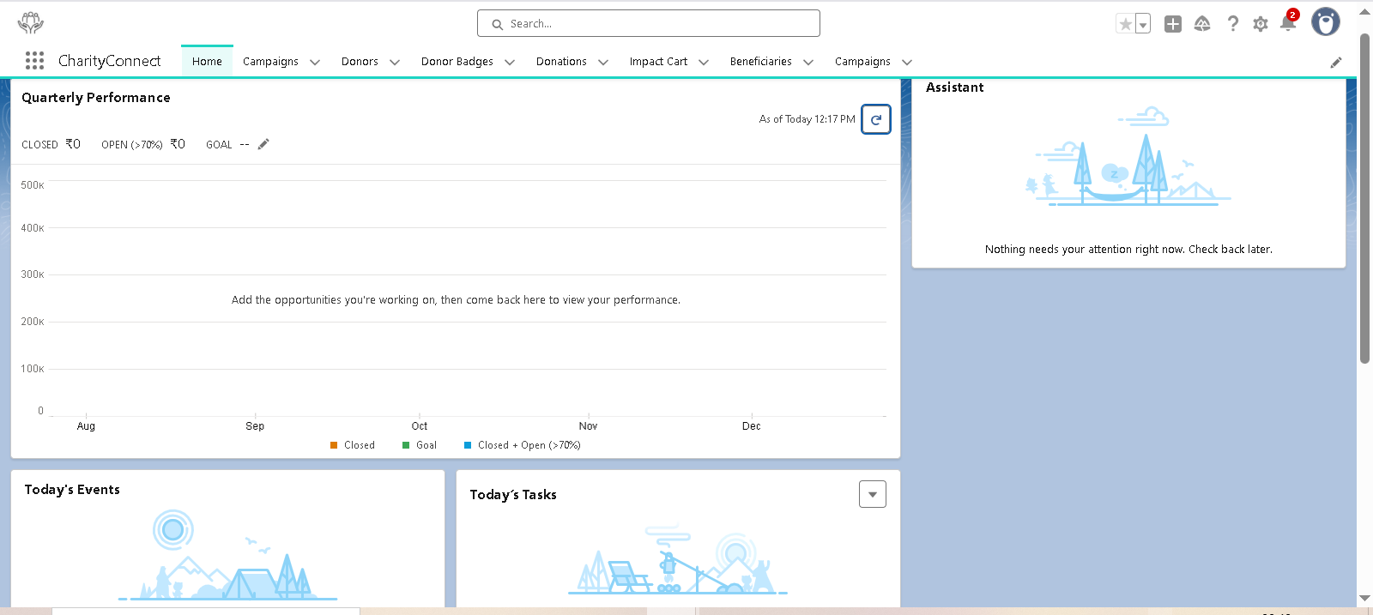 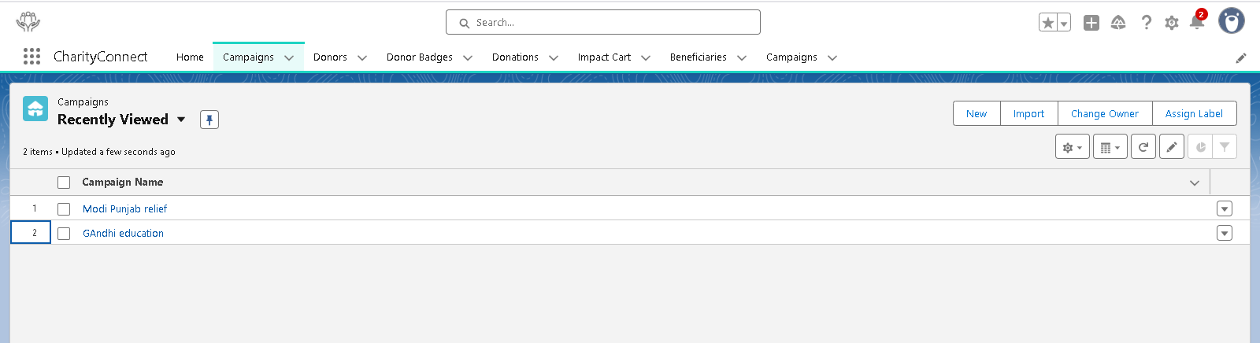 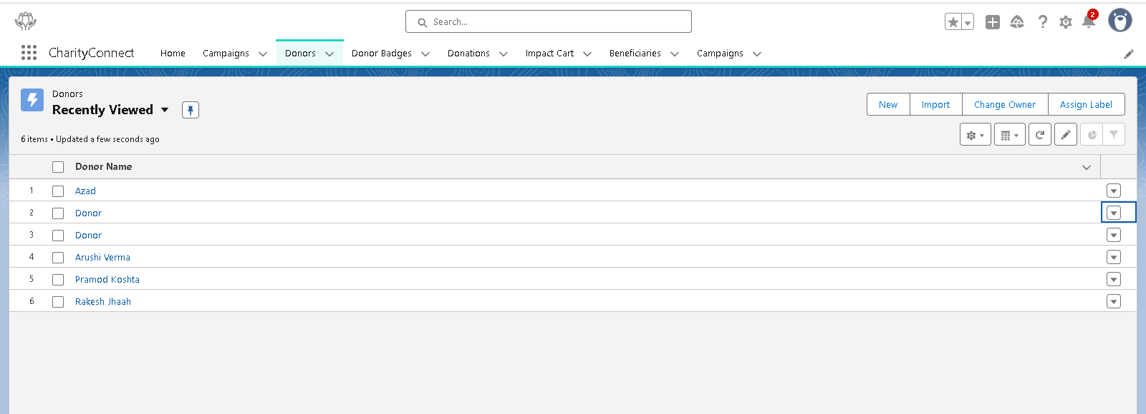 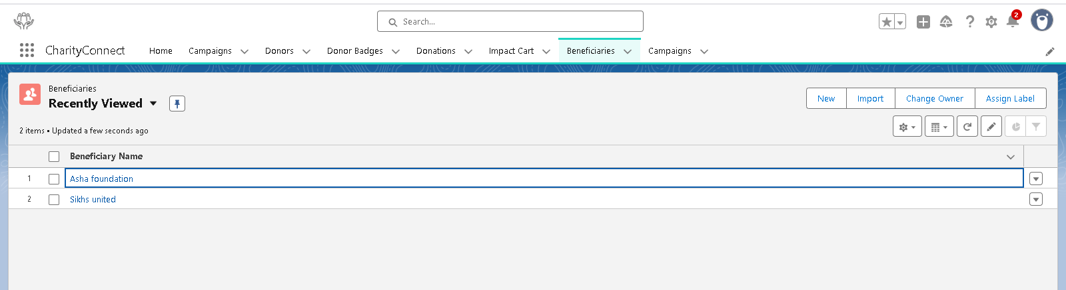**

**LWC component**

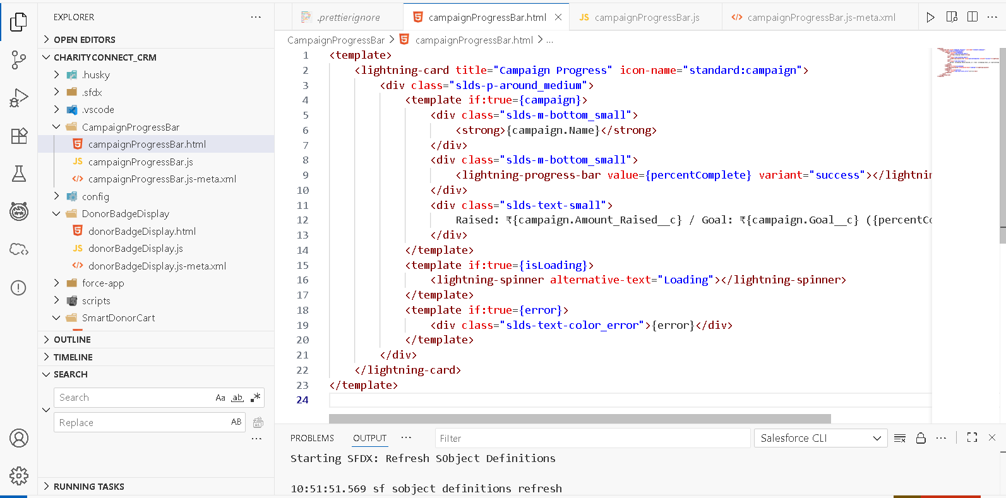

**Rest uploaded in git**